

DATE: December 6, 2015

To: CUSTOMS OFFICIALS

SUBJECT: TRAVEL WITH ORGANIZATION LAPTOP COMPUTER

Graduate Engineering & Science Students Association is a student body associated with Arizona State University, Tempe, USA.

______________________________ is GESSA organization volunteer carrying an organization -owned laptop computer brand _______________ Model _________________.

The individual identified is temporarily exporting the laptop computer, software and data described above and will return them to the United States within one year from departure. These goods will remain in the individual’s possession and control for the duration of the temporary export. These goods are for the individual’s use only and are not for sale or sale on approval.

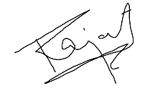

Rajat Aggarwal

GESSA Travel Supervisor